ST 352

**Lab Assignment 7**

***25 points***

***Due 11:59 PM on Friday, November 29***

The questions on this assignment pertain to the **moth** example from the Lab 7 Notes:

According to The Missouri Angler web page (<https://www.missoulianangler.com/spruce-moth/>), “the larvae of spruce moths hatch in the tops of coniferous trees and burrow into the base of the pine needles to feed. This will kill the top of the tree, doing tremendous damage in the forest.”

To learn more about spruce moths, researchers set traps in four different parts of trees (top branches, middle branches, lower branches, or ground beneath the tree) and used three different types of lures (scent, sugar, or chemical). The number of moths found in the traps after 48 hours was recorded.

The following variables are recorded in the **moths** data set, (found in the Lab 7 Notes page as well as in the Lab Assignment 7 page on Canvas):

**number:** This is our response variable. This is the number of spruce moths found in traps after 48 hours

**location:** This will be our first factor. This is the location of trap in tree (top branches, middle   
branches, lower branches, or ground)

**lure:** This will be our second factor. This is the type of lure in trap (scent, sugar, or chemical)

1. ***(1 point)*** In the Lab 7 Notes, you used the aggregate() command to obtain the mean number of spruce moths trapped after 48 hours for each combination of *location* and *lure*. Present the means in a table of means, such as the one given below. (Do not copy and paste the output from the aggregate() command as you want to present a more “readable” table of means!)

Type of lure

|  |  |  |  |
| --- | --- | --- | --- |
| location | scent | sugar | chemical |
| Top branches | **21.4** | **25.6** | **23.0** |
| Middle branches | **27.8** | **33.4** | **31.8** |
| Lower branches | **32.8** | **31.2** | **36.0** |
| ground | **17.0** | **21.0** | **19.2** |

2. ***(1 point)*** Also in the Lab 7 Notes, you created an ***interaction plot***. Include the properly labeled interaction plot here.

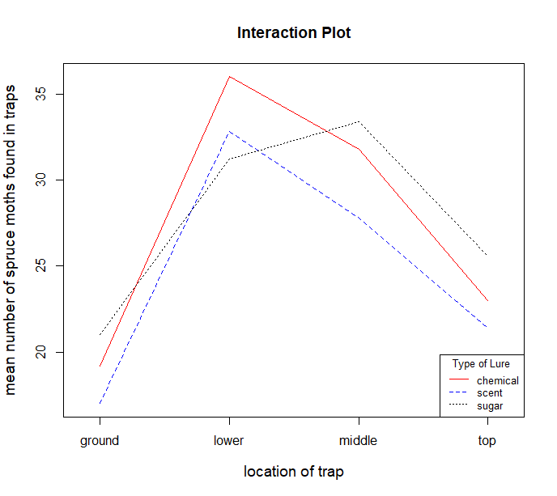

***Make sure plot has a legend. If not, deduct ½ point.***

3. ***(2 points)*** **Based on the interaction plot and/or table of means only**, do you believe there is a main effect of *location*? Briefly explain.

**Overall it appears there were fewer moths caught on the ground, the most were caught at the lower level and then middle then top. This would indicate that there is a main effect of location since the mean # of spruce moths trapped is different for at least one of the locations.**

**+1 for saying “yes”**

**+1 for proper support using just features in the interaction plot**

4. ***(2 points)*** Again, **based on the interaction plot and/or table of means only**, do you believe there is a main effect of *lure*? Briefly explain.

This one is a bit subjective. With the exception of the lower level, it appears that the scent resulted in the fewest caught moths, on average. This would be support to say there is a main effect of lure. However, all three lines are close (indicating similar means at each location for all three lures) and some lines even cross. This could be support that there is not a main effect of lure. Look for proper support when grading.

+2 for proper support to whichever decision they make about the main effect of lure. Support should come only from features in the interaction plot.

5. ***(2 points)*** **Based only on the interaction plot**, do you believe there is an interaction effect between *location* and *lure*? Briefly explain.

**This is also a bit subjective. Look for support when grading.**

**The lines cross, which would be support that an interaction term is needed – one particular scent may work a little better, on average, at trapping spruce moths for one location, but a different scent may work better at a different location.**

**At the same time, while not perfectly parallel, it looks like the lines are moving similarly from one location to another, which could be support for saying an interaction term is not needed even though there is some crossing of lines.**

**+2 for proper support using the interaction plot only**

6. Next, test for an interaction effect between *location* and *lure*.

a. ***(2 points)*** State the null and alternative hypotheses in words to test if the interaction term is significant in the model.

**H0: The interaction term is not significant in the model.**

**HA: The interaction term is significant in the model.**

**-1.5 if have these reversed**

b. ***(1 point)*** Provide the appropriate test-statistic (make sure to label this test-statistic as either a t-statistic or F-statistic when reporting it!), degrees of freedom and p-value for the interaction term.

**F-stat(6,48) = 0.303, p-value = 0.932.**

**+1/4 each for correct F-statistic, correct numerator df, correct denominator df, and correct p-value**

c. ***(2 points)*** State a conclusion from the test for the interaction term in the context of the problem.

There is no evidence of a significant interaction between lure and the location of the trap.

-1.5 if have incorrect adjective based on their p-value.

7. Finally, test for the main effects. Let’s start by testing for the main effect of *location*.

a. ***(2 points)*** State the null and alternative hypotheses in words to test for the main effect of *location*.

**H0: The main effect of location is not significant in the model.**

**or H0: the mean number of spruce moths trapped is the same for all locations**

**HA: The main effect of location is significant in the model.**

**or HA: the mean number of spruce moths trapped is different for at least one location**

**Accept either way of writing the hypotheses**

**-1.5 if have these reversed (exception: if applied this deduction in question 6, only deduct 1 point for the same error here)**

b. ***(1 point)*** Provide the appropriate test-statistic (make sure to label this test-statistic as either a t-statistic or F-statistic when reporting it!), degrees of freedom and p-value for the main effect of *location*.

**F-stat(3,48) = 10.450, p-value = 0.00002 (or < 0.0001 is acceptable).**

**+1/4 each for correct F-statistic, correct numerator df, correct denominator df, and correct p-value**

c. ***(2 points)*** State a conclusion from the test for the main effect of *location* in the context of the problem.

There is strong evidence to suggest a main effect of location. Or, there is strong evidence to indicate the mean number of spruce moths trapped is different for at least one location.

Accept either way of stating conclusion. -1.5 if have incorrect adjective based on their p-value.

8. Test for the main effect of *lure*.

a. ***(2 points)*** State the null and alternative hypotheses in words to test for the main effect of *lure*.

**H0: The main effect of lure is not significant in the model.**

**or H0: the mean number of spruce moths trapped is the same for all three lure types**

**HA: The main effect of lure is significant in the model.**

**or HA: the mean number of spruce moths trapped is different for at least one lure type**

**Same deduction as above: --1.5 if have these reversed with the exception that if you applied this deduction in questions 6 and/or 7, only deduct 1 point for the same error here**

b. ***(1 point)*** Provide the appropriate test-statistic (make sure to label this test-statistic as either a t-statistic or F-statistic when reporting it!), degrees of freedom and p-value for the main effect of *lure*.

**F-stat(2,48) = 0.894, p-value = 0.416.**

**+1/4 each for correct F-statistic, correct numerator df, correct denominator df, and correct p-value**

c. ***(2 points)*** State a conclusion from the test for the main effect of *lure* in the context of the problem.

There is not enough evidence to suggest a main effect of lure type. Or, there is not enough evidence to indicate the mean number of spruce moths trapped is different for at least one lure type.

Accept either way of stating conclusion. -1.5 if have incorrect adjective based on their p-value.

9. ***(2 points)*** The Bonferroni method was used to construct multiple pairwise t-tests for the different locations. Below is the output from R Studio:

> pairwise.t.test(moths$number, moths$location, p.adjust.method = "bonf")

Pairwise comparisons using t tests with pooled SD

data: moths$number and moths$location

ground lower middle

lower 2.3e-05 - -

middle 0.00044 1.00000 -

top 0.78828 0.00420 0.04791

P value adjustment method: bonferroni

Which locations have significantly different mean number of spruce moths found in traps after 48 hours? Which locations do not have significantly different means? Does this agree with the interaction plot? Briefly explain.

The output suggests a significant difference between the ground and lower level (adjusted p-value = 0.00002 < 0.05), the ground and middle level (adjusted p-value = 0.0004 < 005), the top and lower branches (adjusted p-value = 0.0042 < 0.05), and the top and middle levels (p-value = 0.0479 < 0.05). There is not enough evidence to suggest that the mean number of spruce moths caught is different between the lower and middle level (adjusted p-value = 1) and ground and top level (adjusted p-value = 0.7883). In summary, the means of the lower and middle levels are not significantly different, nor are the means of the ground and top levels, but all other comparisons are significantly different.

Note that the p-values are not required, but their explanations will probably need to include the p-values. They should compare the p-values to 0.05 since the p-values are adjusted in R using the “bonf” adjustment.

+1 for stating or summarizing what locations are different or not different

+1 for proper support